

Niagara Falls City School District

**Elementary Extended Learning Program (ELP)**

Monday, July 14, 2025 - Friday, August 1, 2025

**What:** Free full-day summer program offered by the Niagara Falls City School District

**Who:** ALL Niagara Falls City School District students exiting Pre-K 4 through 5th grade

in June of 2025.

**Where:** 79th Street Elementary School

(Busing will be provided to eligible students. Specific busing information will be sent home closer to the start of the program)

**Days:** Monday, Tuesday, Wednesday, Thursday, and Friday

**Time:** 8:45am – 3:00pm

**More Information:**

* Language Arts and Math activities will take place in the morning, followed by exciting extension activities in the afternoon.
* Breakfast, lunch, and a healthy snack will be served at the summer program.

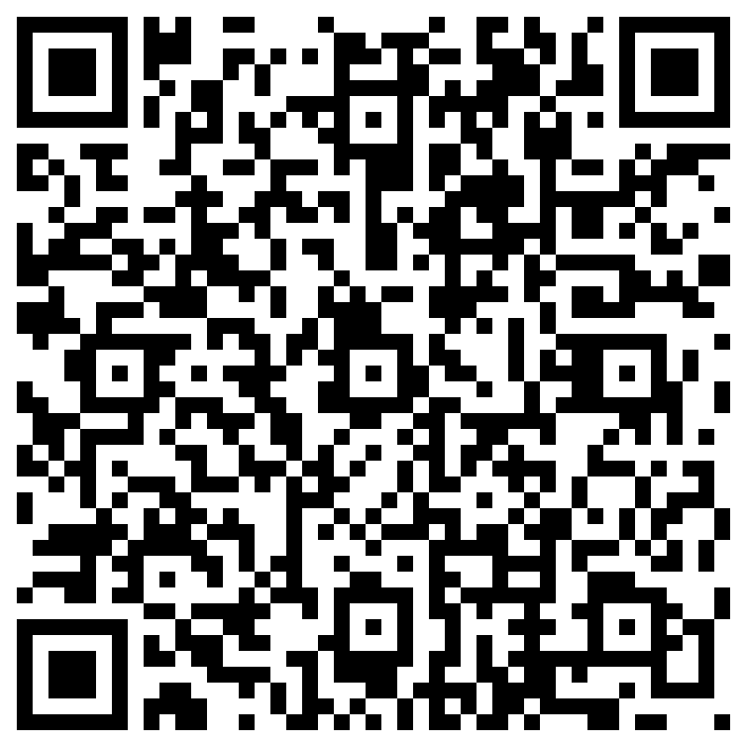

**Applications can be accessed by:**

* Scanning the QR Code
* Logging on to the district website – www.nfschools.net
* Contact your child’s school and they will connect you with an individual that can assist with completing the application.

**Questions:** Call: (716) 286-4299 and leave a message. A program coordinator will respond to each inquiry.

**ALL applications are due by *Friday, May 30,2025***